|  |
| --- |
| Microsoft SharePoint 2013 - Hands-on Lab |
| Social |
| Verified Against Build #15.0.4420.1017 |

|  |
| --- |
| Microsoft  Version 1.0  August 14, 2012 |

Information in this document, including URL and other Internet Web site references, is subject to change without notice. Unless otherwise noted, the example companies, organizations, products, domain names, e-mail addresses, logos, people, places, and events depicted herein are fictitious, and no association with any real company, organization, product, domain name, e-mail address, logo, person, place, or event is intended or should be inferred. Complying with all applicable copyright laws is the responsibility of the user. Without limiting the rights under copyright, no part of this document may be reproduced, stored in or introduced into a retrieval system, or transmitted in any form or by any means (electronic, mechanical, photocopying, recording, or otherwise), or for any purpose, without the express written permission of Microsoft Corporation.

The names of manufacturers, products, or URLs are provided for informational purposes only and Microsoft makes no representations and warranties, either expressed, implied, or statutory, regarding these manufacturers or the use of the products with any Microsoft technologies. The inclusion of a manufacturer or product does not imply endorsement of Microsoft of the manufacturer or product. Links are provided to third party sites. Such sites are not under the control of Microsoft and Microsoft is not responsible for the contents of any linked site or any link contained in a linked site, or any changes or updates to such sites. Microsoft is not responsible for webcasting or any other form of transmission received from any linked site. Microsoft is providing these links to you only as a convenience, and the inclusion of any link does not imply endorsement of Microsoft of the site or the products contained therein.

Microsoft may have patents, patent applications, trademarks, copyrights, or other intellectual property rights covering subject matter in this document. Except as expressly provided in any written license agreement from Microsoft, the furnishing of this document does not give you any license to these patents, trademarks, copyrights, or other intellectual property.

Copyright © 2012 Microsoft Corporation. All rights reserved.

Microsoft and SharePoint are either registered trademarks or trademarks of Microsoft Corporation in the United States and/or other countries.

The names of actual companies and products mentioned herein may be the trademarks of their respective owners.

# Introduction

## Estimated time to complete this lab

60 minutes

## Objectives

After completing this lab, you will be able to:

* Setup Profile Imports
* Setup and use My Sites
* Utilize the Microfeed in a custom solution
* Setup and use Communities

## Overview of Lab

In this lab, you will walk through all the necessary steps to set up the Social capabilities of SharePoint. After setting up the Social facilities, you will utilize the new capabilities of My Sites including the Microfeed. You will then use the Microfeed in a custom solution. Finally, you will set up a new Community site.

## Virtual Machine Technology

The computers in this lab are virtual machines that are implemented using Microsoft Hyper-V. Before starting each virtual machine, ensure you apply the **Start-Lab** snapshot. When you have started a virtual machine, log on by pressing **CTRL+ALT+END** and supply the credentials listed in the lab instructions.

## Computers in this lab

This lab uses virtual machines as described in the following table. Before you begin the lab, you must start the virtual machines and then log on to the computers.

|  |  |
| --- | --- |
| **Virtual Machine** | **Role** |
| {Supplied by Instructor} | Domain Controller |
| {Supplied by Instructor} | Actual SharePoint environment with Office client and other required software. |

All user accounts in this lab use the password {Supplied by Instructor}.

# Exercise 1: Profile Imports and My Sites

In this exercise, you will set up profile imports for a group of new users and programmatically create their personal sites.

## Task 1 – Create an Organizational Unit and Group in Active Directory

* Begin this task logged on to **DC** as **CONTOSO\Administrator**.

1. Log into the domain controller as a Domain Administrator (CONTOSO\administrator).
2. Open **Active Directory Users and Computers**.
3. If one does not exist, create an Organizational Unit named **Employees**.



1. In the new **Employees** organizational unit, create a new group **PortalUsers**.



## Task 2 - Add new user accounts to Active Directory

In this task, you will import several new user accounts into Active Directory.

* Begin this task logged on to **DC** as **CONTOSO\Administrator**.
* This task requires the **Import.bat**, **users.txt**, and **ImportUsers.ps1**, and **ResetAllPasswords.ps1** files be copied to the c:\temp directory on the domain controller.

1. Copy the contents of the **Setup** directory in your hands on lab folder to the **c:\temp** folder on the domain controller.

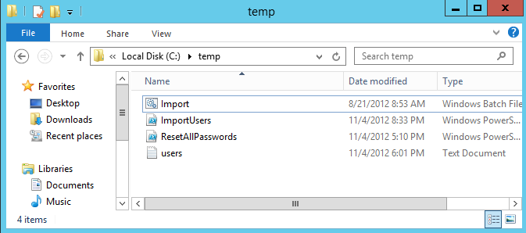

1. Run a **Command Prompt** as Administrator.
2. In the Command Prompt window, execute a **CD** command to change the current directory to **c:\temp**.
3. Execute the **Import.bat** file to import the new user accounts into Active Directory.
4. Run **Windows PowerShell ISE** As Administrator.
5. In Windows PowerShell ISE< select **File⮚Open**.
6. Browse to the file **ResetAllPasswords.ps1** and select **Open**.
7. Make note of the password in the script and push the **F5** key to run the script and reset all the passwords for the newly-imported accounts.
8. Verify the new accounts are created in Active Directory in the Employees Organizational Unit.

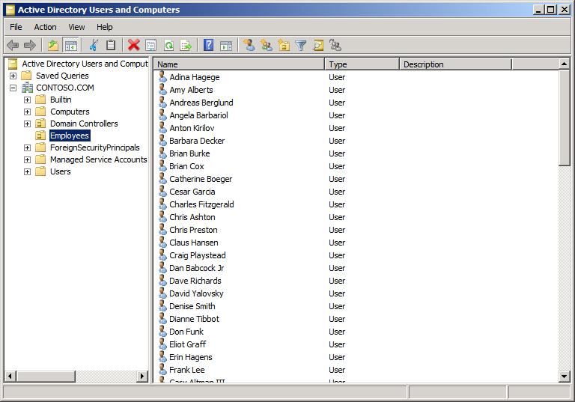

* + - * + New accounts added to Active Directory

## Task 2 – Import Profiles

In this task, you will import the profiles for the new accounts.

* Begin this task logged on to **SP** as **CONTOSO\Administrator**.

1. Open **Central Administration**.
2. On the home page, select **Application Management⮚Manage Service Application**.
3. On the Service Application page, click **User Profile Service Application**.
4. On the Manage Profile Service page, select **Synchronization⮚Configure Synchronization Settings**.
5. On the Configure Synchronization Settings page, **Use SharePoint Active Directory Import**.
6. Click **OK**.
7. On the Manage Profile Service page, select **Synchronization⮚Configure Synchronization Connections**.
8. On the Synchronization Connections page, click **Create New Connection**.
9. Enter **Contoso Employees** in the **Connection Name** field.
10. Enter **contoso.com** in the **Fully Qualified Domain Name** field.
11. Enter the User Profile Service Account name in the **Account Name** field (for example, **CONTOSO\sp_profileimport**).
12. Enter the password for the account in the **Password** and **Confirm Password** fields.
13. Click **Populate Containers**.
14. Expand the **CONTOSO** node and check the **Employees** node and the **Users** node.
15. Click **OK**.

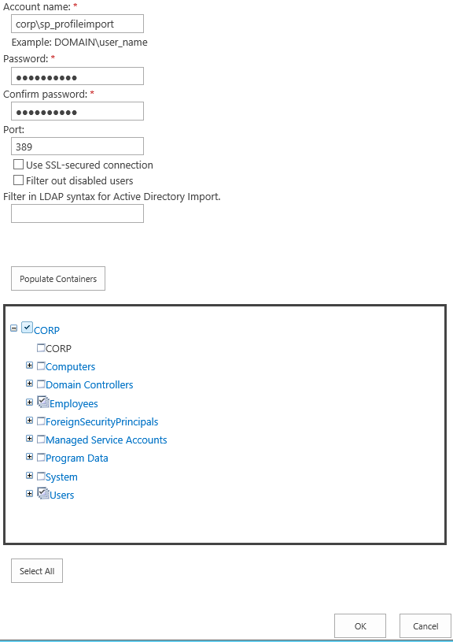

* + - * + Specifying to import accounts from the Employees OU

1. On the **Manage Profile Service** page, click **Synchronization⮚Start Profile Synchronization**.
2. Select to perform a **Full Synchronization**.
3. Wait for the Profile Import to complete before proceeding.

## Task 3 –Create My Sites

In this task, you will programmatically create personal sites for the new accounts that were imported. This is important because users cannot participate in most of the Social features if they do not have a personal site.

* Begin this task logged on to **SP** as **CONTOSO\SP_Farm.**

1. On the Manage Profile Service page, click **My Site Settings⮚Setup My Sites**.
2. Note the value of the **My Site Host**.
   * + - * If you do not have a My Site Host, you cannot continue with the lab. Stop and check with your instructor.

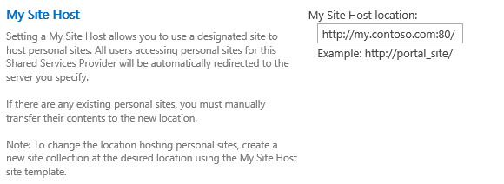

* + - * + Determine the My Site Host URL
        + The actual URL for your machine may be different than the one shown in the figure above.
  1. Run **Windows PowerShell ISE** As Administrator.

1. In Windows PowerShell ISE, select **File⮚Open**.
2. Browse to the file **CreateMySites.ps1** and select **Open**.
3. Edit the script to reflect the **My Site Host** you recorded earlier.
4. Push the **F5** key to run the script and create personal sites.

## Task 4 –Grant Permissions

In this task, you will grant access to the new accounts.

* Begin this task logged into **DC** as **CONTOSO\Administrator.**

1. Launch the **Active Directory Users and Computers** applet.
2. Right-click the **Employees** OU and select **New⮚Group** from the context menu.

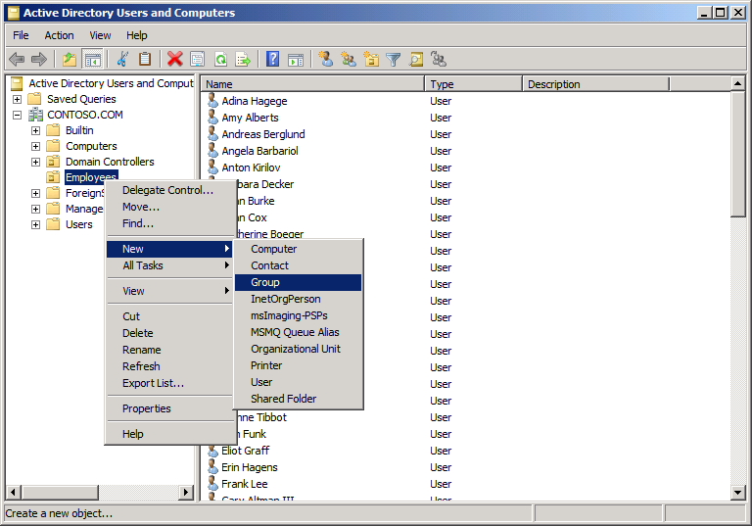

* + - * + Create a New Group

1. Name the group **PortalUsers** and click **OK**.
2. Add all of the employees to the group.
3. Reset the password for the accounts **Patricia Doyle, David Yalovsky**, and **Brian Cox**, which will be used later in the lab.
   1. Right click the account and select **Reset Password**
   2. In the **New Password** and **Confirm Password** fields, enter **P@ssw0rd**
   3. Click **OK**.
4. **Navigate** to the home page of the SharePoint Site Collection where you will work on this exercise.
5. Click **Share**.
6. In the Share dialog, click **Invite People**.
7. Enter **CONTOSO\PortalUsers** and click **Share**.

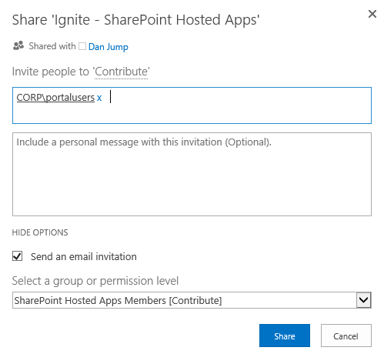

* + - * + Share the Site

# Exercise 2: Using Social Features

In this exercise, you will utilize some of the social features of SharePoint 2013.

## Task 1 - Sharing Activities and Documents

In this task, you will share activities and documents with other users.

* Begin this task logged on to **SP** as **CONTOSO\PatriciaD.**

1. Log in to the SharePoint portal using the account **CONTOSO\patriciad**.
   * + - * Patricia Doyle is the President and CEO. So she is likely to have many followers interested in the information she shares.
   1. On the portal home page, click **SkyDrive**.
   2. If prompted, allow SharePoint to change your settings to support the Social features.

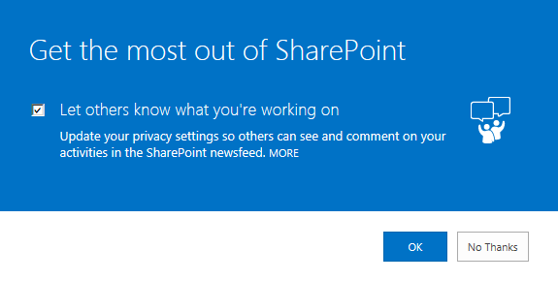

* + - * + Update privacy Settings
  1. Click the **Shared with Everyone** folder.
  2. Click **New Document.**
  3. In the Add a Document dialog, **Browse** to the file **Contoso Limited.docx** and select **Open**.
  4. Click **OK**.
  5. Click the ellipsis associated with the document and select **Share** from the menu.
  6. In the Share dialog, enter **CONTOSO\PortalUsers** and click **Share**.

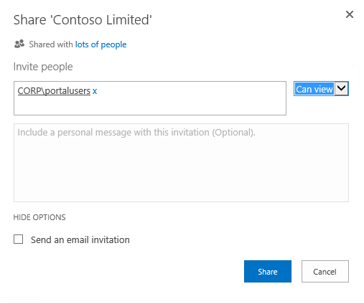

* 1. Click **Newsfeed**.
  2. Enter the following message in the **Share something with everyone** field and click **Post**.

I’m pleased to announce the merger with Fabrikam, Inc is complete. Many thanks to every one of you who worked so hard to make it happen! I have shared a memo outlining the merger so the entire staff can read the details.

## Task 2 - Follow People, Sites, and Documents

In this task, you will people, sites, and documents.

* Begin this task logged on to **SP** as **CONTOSO\BrianC.**

1. Log in to the SharePoint portal using the account **CONTOSO\brianc**.
   * + - * Brian Cox is a Solutions Developer at Contoso. He wants to follow the Activities of the President.
   1. Click **Newsfeed**.
   2. Click **Follow**.
   3. Click **Follow** again.
   4. In the Follow People dialog, enter **CONTOSO\patriciad** and click **Follow**.
   5. Click the ellipsis next to Patricia Doyle to see her activities.

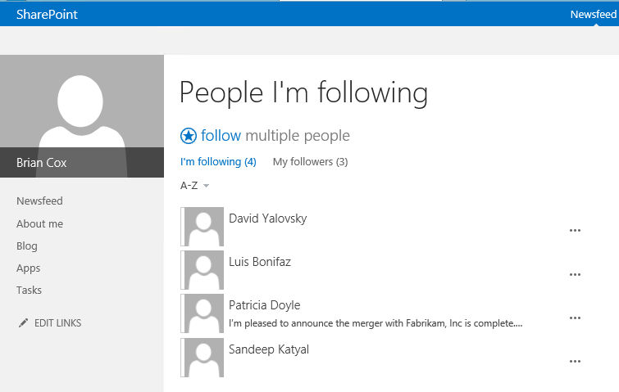

* + - * + See activities from those you are following
  1. Click **See Conversation**.
  2. In the thread, click **Like**.
  3. Click **Reply**, enter the following message, and click **Post**.

Great news for the company! Congratulations to all!

* 1. Click **Patricia Doyle**.
  2. Click **Documents**.
  3. Click the ellipsis associated with the **Contoso Limited** document.
  4. Click **Follow**.

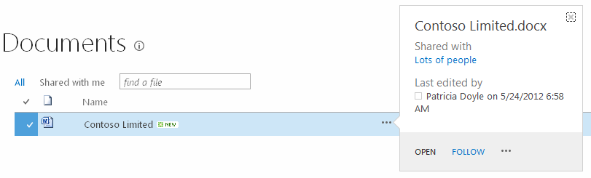

* + - * + Follow a document
  1. Click **Newsfeed**. Click the elipses to see **Activities**.

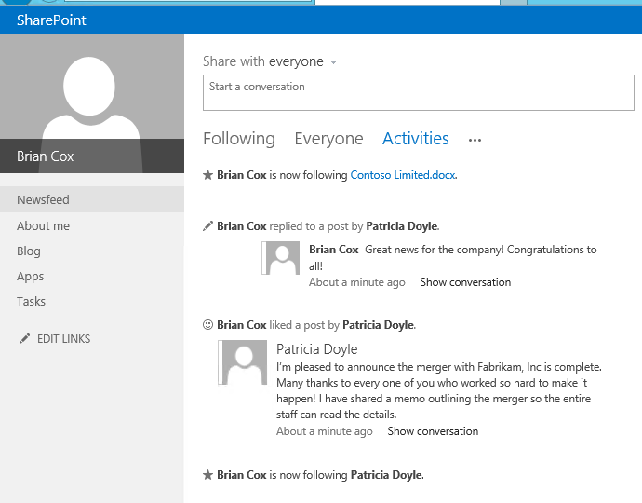

* 1. **Navigate** to the home page of the Site Collection you are using for the exercise.
  2. **Click** the star near the Site menu to start following the site.
  3. Click **Newsfeed**.
  4. Click **Activities** to see the documents you are following.

# Exercise 3: Programming the Microfeed

In this exercise, you will create a custom solution that uses the Microfeed API to read and write activities.

## Task 1 – Create the Windows Application

In this task, you will create the windows application project.

1. Open Microsoft Visual Studio 2012 and create a new Console Application
   1. **Open** Microsoft Visual Studio 2012
   2. Select **File⮚New Project** from the main menu
   3. Click the **Templates⮚Visual C#⮚** node and select the **Windows Form Application** template
   4. Name the new project **FeedDeck**
   5. Click the **OK** button

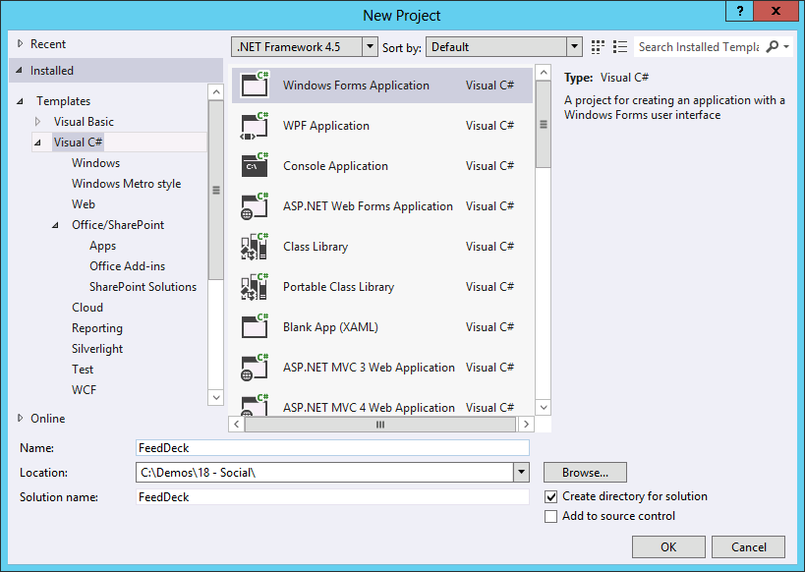

* + - * + Create a new Windows Application project

1. Open the Toolbox and add controls to the form.
   1. Select **View⮚Toolbox** from the main menu in Visual Studio.
   2. Add 3 **TextBox** controls, 1 **NumericUpDown** control, and 2 **Button** controls to **Form1**.
   3. Name the **TextBox** controls **accountName**, **feedThreads**, and **responsePost**.
   4. Set the **MultiLine** property for the **feedThreads** control to **True**.
   5. Name the **NumericUpDown** control **threadCount**.
   6. Name the buttons **getActivities** and **postReply**.
   7. Set the **Text** property of the **getActivities** control to **Get Activities**.
   8. Set the **Text** property of the **postReply** control to **Post Reply**.
   9. **Arrange** the controls on the form as shown in the following figure.

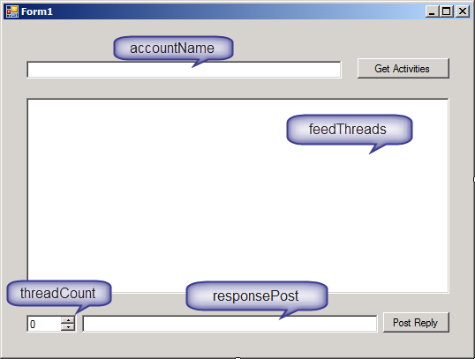

* + - * + Create the user interface

## Task 2 – Code the Application

In this task, you will set references and add code to the application.

1. In the Solution Explorer, right click the **References** node and select **Add Reference**.
2. Click **Browse** and Navigate to **\Program Files\Common Files\Microsoft Shared\web server extensions\15\ISAPI**
3. **Select** the following assemblies and click **Add**.

* Microsoft.SharePoint.Client.dll
* Microsoft.SharePoint.Client.Runtime.dll
* Microsoft.SharePoint.Client.UserProfiles.dll

1. In the **Reference Manager** dialog, click **OK**.
2. Open **Form1.cs** for editing.
3. **Add** the following statements to the top of the code file.

using Microsoft.SharePoint.Client;

using Microsoft.SharePoint.Client.Microfeed;

using Microsoft.SharePoint.Client.UserProfiles;

* + - * + After the above statements are added, you will notice that the dev environment detects ambiguity in the reference to the Form class. The next step will clear up this error.

1. **Fully qualify** the reference to the Form class by **altering** the class definition to appear as follows:

public partial class Form1 : System.Window.Forms.Form

1. Add the following member variables to the Form1 class.

ClientContext clientContext;

MicrofeedManager microfeedMgr;

Dictionary<int, string> idDictionary;

1. **Add** the following code to establish a client context for the application.
   * + - * Be sure to alter the URL to match the Site Collection for you lab environment.

private void Form1_Load(object sender, EventArgs e)

{

clientContext = new ClientContext([URL for Site Collection]);

}

1. **Add** the following code to retrieve the activities for a given user account.

private void LoadThreads()

{

try

{

feedThreads.Text = string.Empty;

string targetUser = accountName.Text;

// Get the MicrofeedManager object.

microfeedMgr = new MicrofeedManager(clientContext);

// Get the properties for the target user

PersonProperties personProps =

new PeopleManager(clientContext).GetPropertiesFor(targetUser);

// Get Display Name and Account Name for the target user

clientContext.Load(personProps, o => o.DisplayName, o => o.AccountName);

clientContext.Load(microfeedMgr);

clientContext.ExecuteQuery();

// Specify the feed content that you want to retrieve.

MicrofeedRetrievalOptions retrievalOptions =

new MicrofeedRetrievalOptions();

retrievalOptions.IncludedTypes = MicroBlogType.RootPost;

retrievalOptions.ThreadCount = 5;

// Get all of the target owner's posts and activities

ClientResult<MicrofeedThreadCollection> threads =

microfeedMgr.GetPublishedFeed(

personProps.AccountName,

retrievalOptions,

MicrofeedPublishedFeedType.Full);

clientContext.ExecuteQuery();

//Create a dictionary to store the thread identifiers

idDictionary = new Dictionary<int, string>();

for (int i = 0; i < threads.Value.Count; i++)

{

MicrofeedThread thread = threads.Value[i];

// Keep only user-sourced threads (not events).

if (thread.DefinitionName ==

"Microsoft.SharePoint.Microfeed.UserPost")

{

//Save thread identifier

idDictionary.Add(i, thread.Identifier);

// Write out the text of the post.

feedThreads.Text += (

personProps.DisplayName + ": " +

(i + 1) + ". " + thread.RootPost.Content + "\r\n");

}

}

threadCount.Maximum = threads.Value.Count;

}

catch (Exception x)

{

MessageBox.Show(x.Message);

}

}

1. **Add** the following code to initiate the retrieval of activities.

private void getActivities_Click(object sender, EventArgs e)

{

LoadThreads();

}

1. Press **F5** to debug the application.
2. Enter **CONTOSO\patriciad** in the **accountName** TextBox and click **Get Activities**.

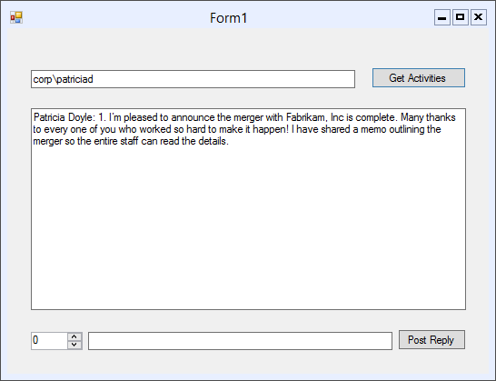

* + - * + Test activity retrieval

1. Select **Debug⮚Stop Debugging** from the main menu in Visual Studio.
2. **Add** the following code to post a reply to an activity thread.

private void postReply_Click(object sender, EventArgs e)

{

try

{

string threadId = string.Empty;

//Get the thread identifier

idDictionary.TryGetValue(

(int)(threadCount.Value - 1), out threadId);

// Define properties for the reply.

MicrofeedPostOptions postOptions = new MicrofeedPostOptions();

postOptions.Content = responsePost.Text;

// Register the reply.

microfeedMgr.PostReply(threadId, postOptions);

// Make the changes on the server.

clientContext.ExecuteQuery();

MessageBox.Show("Reply Posted!");

}

catch (Exception x)

{

MessageBox.Show(x.Message);

}

}

1. Press **F5** to debug the application.
2. Enter **CONTOSO\patriciad** in the **accountName** TextBox and click **Get Activities**.
3. After the activities load, select **1** in the **threadCount** control to indicate that you want to reply to the first thread.
4. **Enter** the following in the **responsePost** TextBox and click **Post Reply**.

@brianc did a fantastic job on the web site

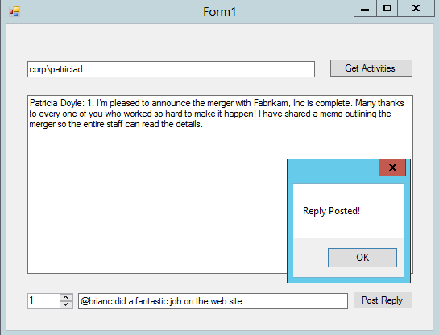

* + - * + Reply to a post

1. **Review** Patricia Doyle’s activity feed in the browser to verify the post was made and that Brian Cox is properly mentioned.

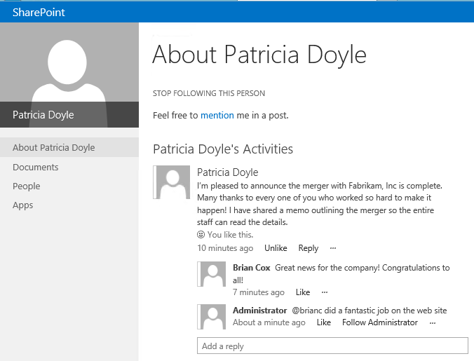

* + - * + Posting a reply

# Exercise 4: Setting up a Community

In this exercise, you will create a new Community site in SharePoint 2013.

## Task 1 - Create the Community Site

In this task, you will create the Community site using the new template.

1. **Navigate** to the home page of the Site Collection you are using for the exercise.
2. Click the **Site Contents link** and click **New Subsite**.
   1. On the **New Site** page, enter **SharePoint Support** in the **Title** field.
   2. Give the site a **Description**.
   3. Enter **spsupport** in the **URL Name** field.
   4. Select **Community Site** as the template.
   5. Click **Create**.

## Task 2 – Create a discussion

* Begin this task logged on to **SP** as **CONTOSO\BrianC**.

1. Log into the SharePoint Support site as **CONTOSO\BrianC**.
2. Create a new discussion. Enter some clever text in the subject and body, and use the **General** category for the post. This will ensure that some data is available for the site so that the administrator can gift a badge to the user.

## Task 3 - Configure the Community Site

In this task, you will configure the various options in the Community site.

* Begin this task logged on to **SP** as **CONTOSO\Administrator**.

1. On the home page of the SharePoint Support site, click **Create Categories**.
   1. In the Categories list, click **New Item**.
   2. Enter **Setup, Upgrade, Administration, and Operation** in the **Category Name** field.
   3. Enter **Discuss setup, upgrade, administration and operation for SharePoint 2010 and SharePoint services such as Access Services, BCS, Excel Services and Visio Services** in the **Description** field.
   4. Click **Save**.
   5. In the Categories list, click **New item**.
   6. Enter **Using SharePoint Designer, InfoPath, and Other** field.
   7. Enter **Discuss using SharePoint Designer, SharePoint Gallery Solutions, templates & other customization for SharePoint 2010 and SP services such as Access Services, BCS, Excel Services, & Visio Services** in the **Description** field.
   8. Click **Save**.
   9. In the Categories list, click **New Item**.
   10. Enter **Using Visual Studio with SharePoint and other programming** field.
   11. Enter **Discuss using Visual Studio and other programming with SharePoint 2010 and SharePoint services such as Access Services, BCS, Excel Services and Visio Services** in the **Description** field.
   12. Click **Save**.
2. On the home page of the SharePoint Support site, click **Reputation Settings** and review the various settings that can be attributed to reputation.
3. On the home page of the SharePoint Support site, click **Create Badges.**
   1. Click new item.
   2. In the **Badge Title** screen, type **Moderator.**
4. On the home page of the SharePoint Support site, click **Assign badges to members.**
   1. Click **Manage the List of Gifted Badges**.
   2. Click **Add**.
   3. Enter **Moderator** in the **Badge Name** field.
   4. Click **Save**.
5. On the home page of the SharePoint Support site, click **Assign Badges to members**.
   1. In the Members list, select your record and click **Moderation⮚Give Badge** in the ribbon.
   2. Select **Moderator** as the Gifted Badge.
   3. Click **Save**.

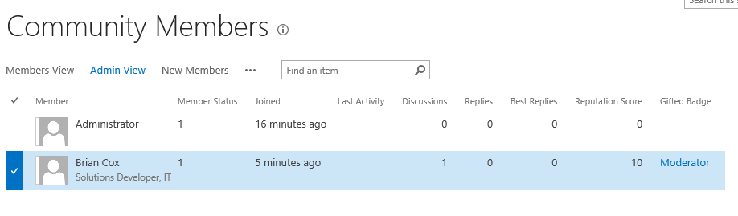

1. On the home page of the SharePoint Support site, click **Community Settings**.
   1. Check **Enable Reporting of Offensive Content**.
   2. Click **OK**.

## Task 3 - Using the Community Site

In this task, you will post content to the community site.

1. Log into the SharePoint portal as **CONTOSO\brianc**.
2. **Navigate** to the home page of the SharePoint Support site.
3. Click **Start a New Discussion**.
   1. Enter **Using SharePoint Search in an App** in the **Subject** field.
   2. Enter **What permissions are required to use SharePoint Search from an App?** In the **Body** field.
   3. Check the **Question** box.
   4. Click **Save**.
4. Log into the SharePoint portal as **CONTOSO\administrator**.
5. **Navigate** to the home page of the SharePoint Support site.
   1. Click **Manage Discussions**.
   2. In the Discussions list, select the discussion started by Brian Cox and choose **Items⮚Edit Item** from the ribbon.
   3. Change the Category to **Using Visual Studio with SharePoint and other programming**.
   4. Click **Save**.
   5. **Return** to the home page of the SharePoint Support site.
   6. Click **Using Search in a SharePoint App**.
   7. Enter **Moved to programming category** and click **Reply**.
6. Log into the SharePoint portal as **CONTOSO\davidy**.
7. **Navigate** to the home page of the SharePoint Support site.
   1. Click **Using Search in a SharePoint App**.
   2. Enter **In Beta 1 the permission is:**  
      **Scope=http://search/query  
      Right=QueryAsUserIgnoreAppPrincipal  
      but in Beta 2 it will be:  
      Scope=http://sharepoint/search Right=QueryAsUserIgnoreAppPrincipal**
   3. Click **Reply**.

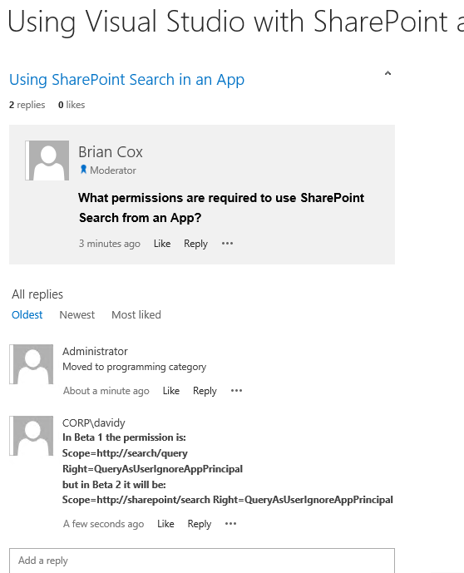

* + - * + Using the Community Site